Template for Evidence(s)
UI GreenMetric Questionnaire

University : ……
Country : ……
Web Address : ……

[1] [Setting & Infrastructure]
SAMPLE
[1.7] Total campus buildings area

Building A | Bulding B
 | 
Area: 15000 m2 | Area: 5000 m2

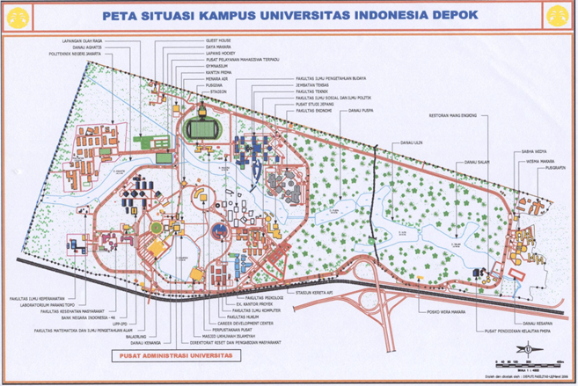

The evidence provided may also include maps showing the location, area size, or distribution of facilities relevant to the indicators

Description:
Building name | Total Area
Building A | 15000 m2
Building V | 5000 m2
Total | 20000 m2

Additional evidence link (i.e., for videos, more images, or other files that are not included in this file):

